TASK ON Terraform -03
1.Watch the Terraform-03 video.
Done watching the video
2.Execute the script shown in the video.
We have created both main.tf and varible.tf files
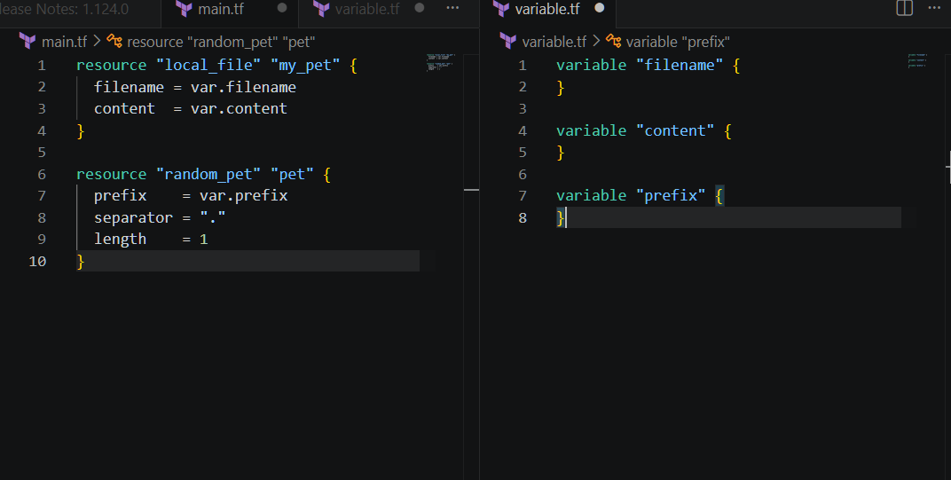
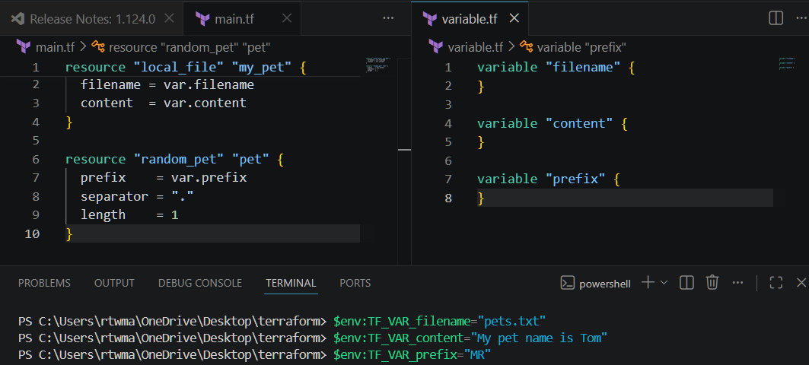
Now lets perform terraform apply
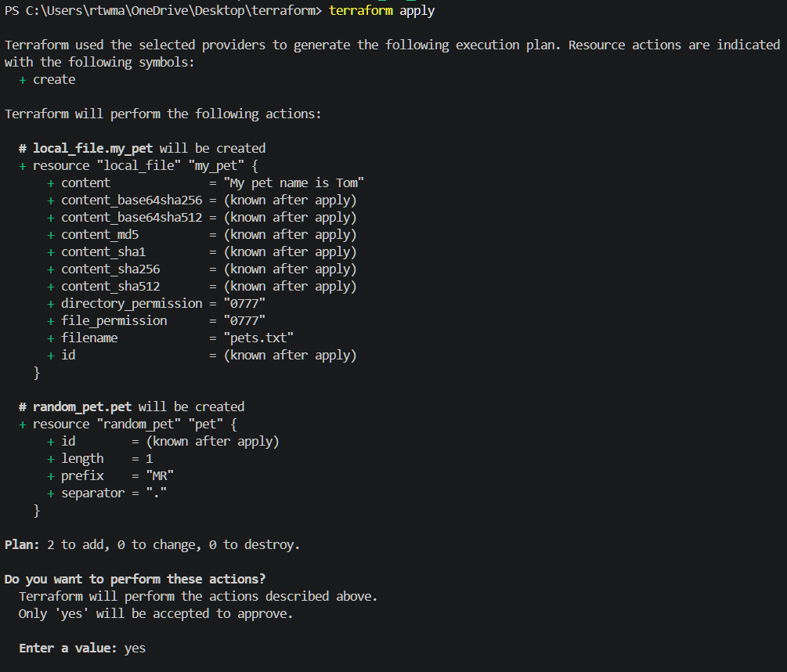
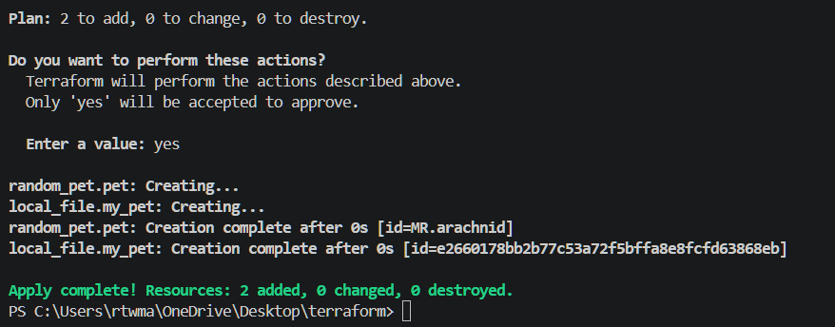
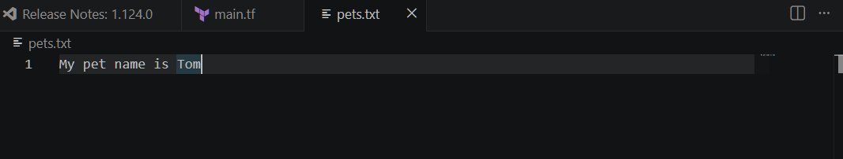
Resource dependency
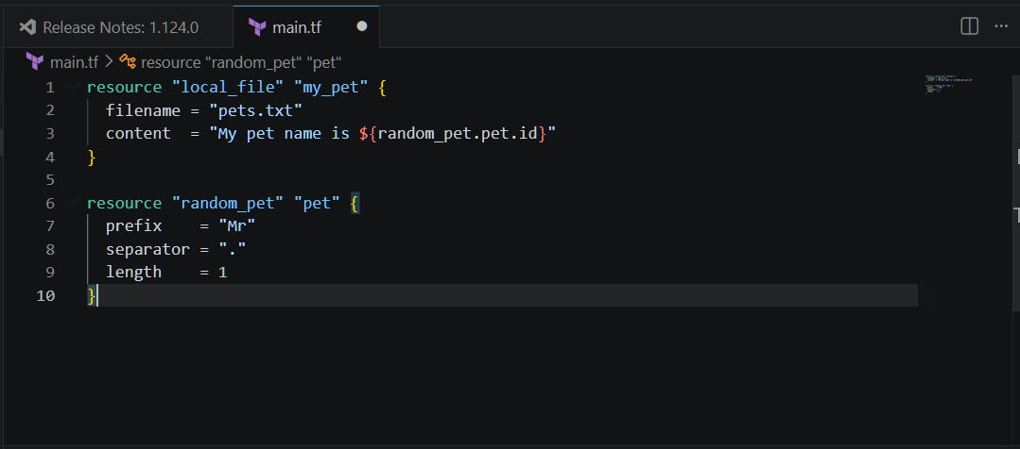
Now perform terraform apply
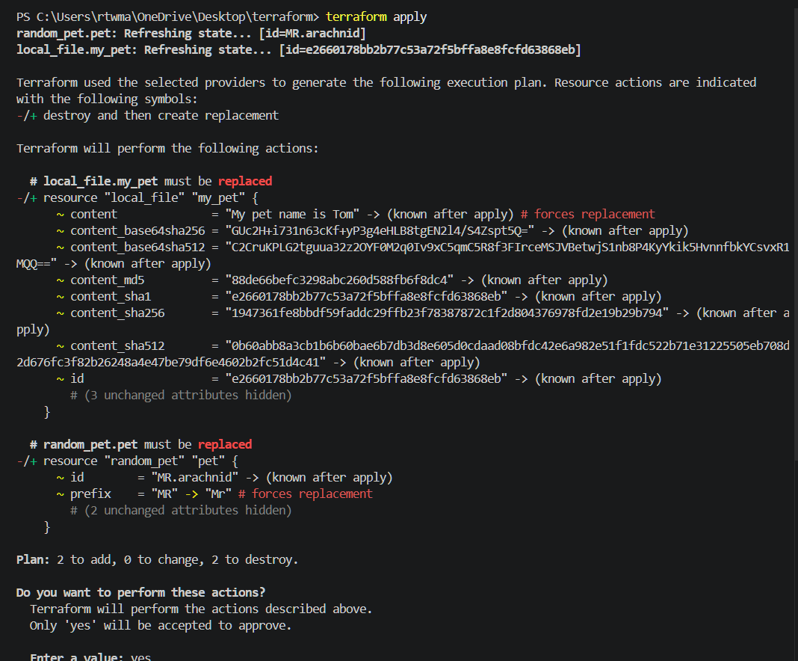
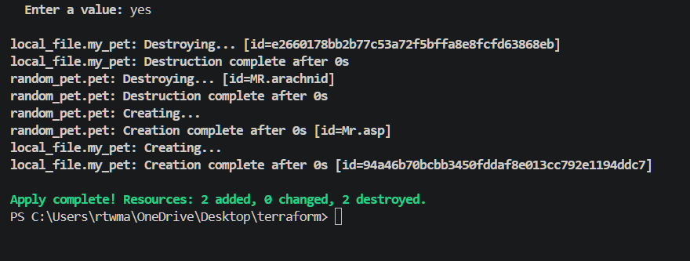
Here the random pet name is created
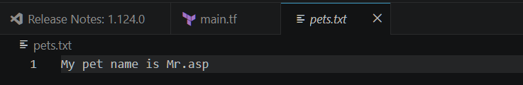
lets use output.tf file
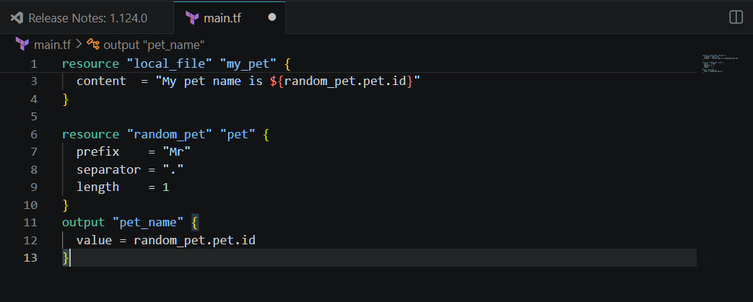
The output name is displayed

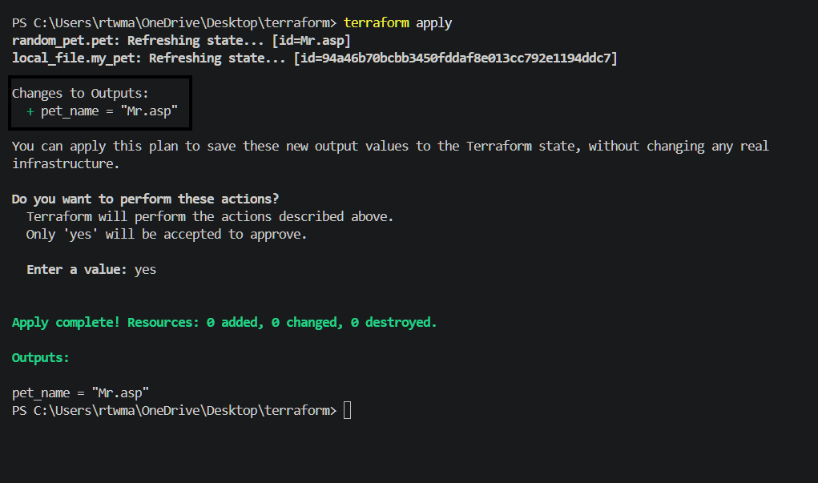
Also by giving terraform output command it will displays the output
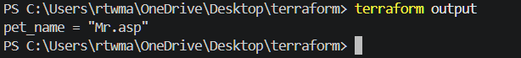
Statefile
By performing terraform show command it will show the statefile
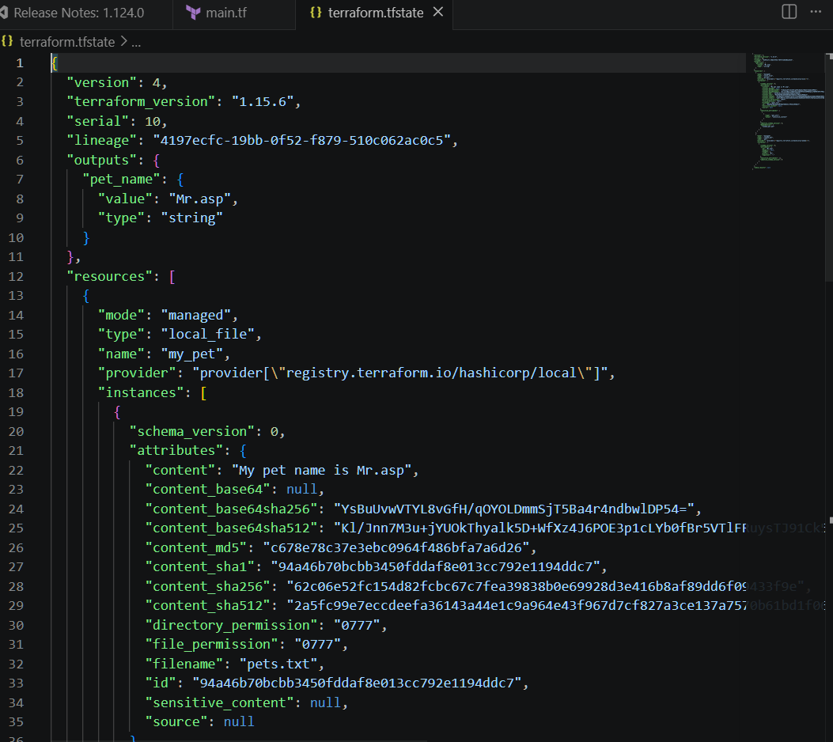
Terraform show

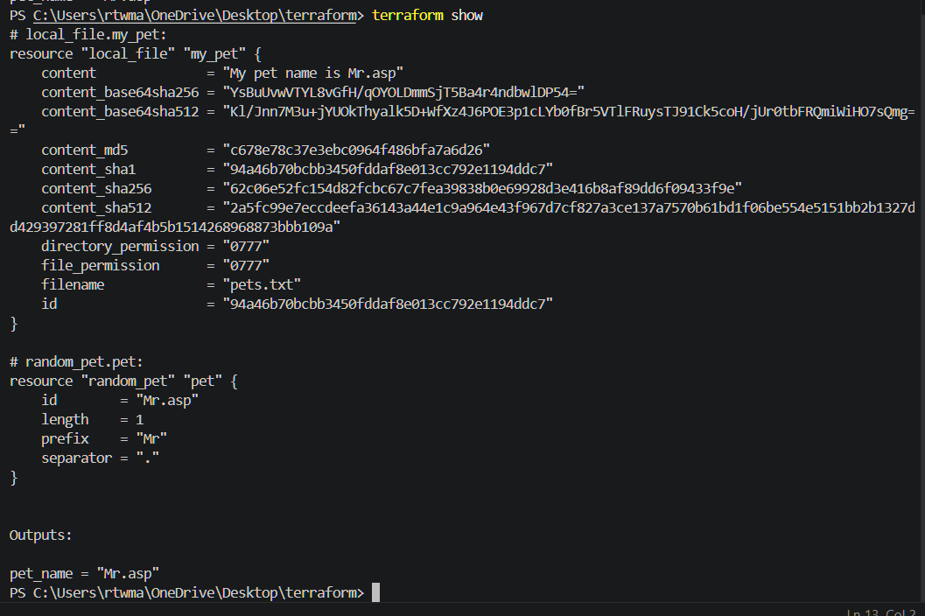
3.Integrate Terraform in Jenkins using the Terraform plugin.
Installed terraform plugin
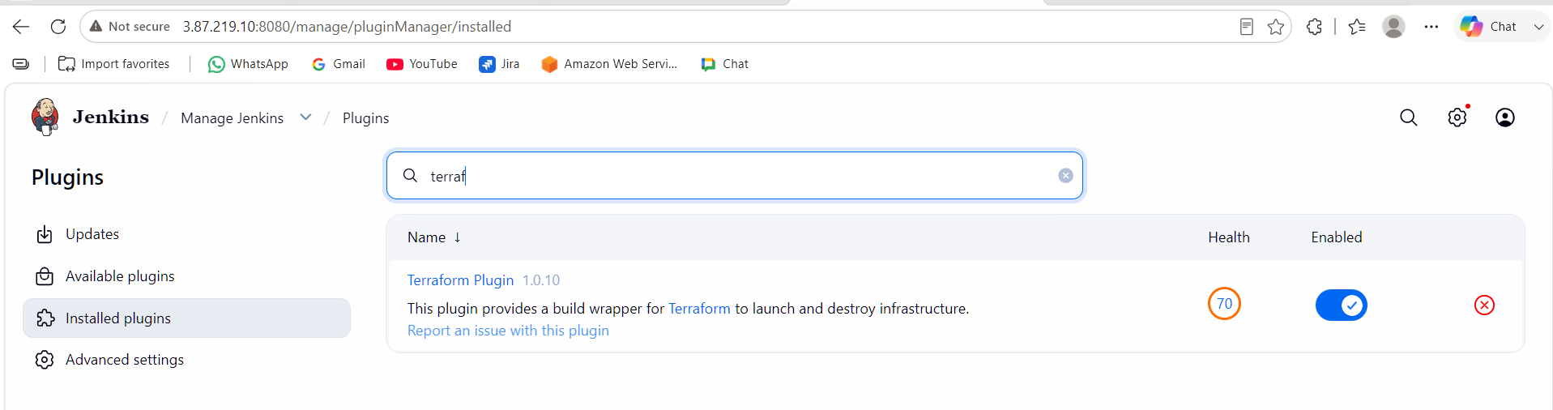
Tools terraform installation give name save
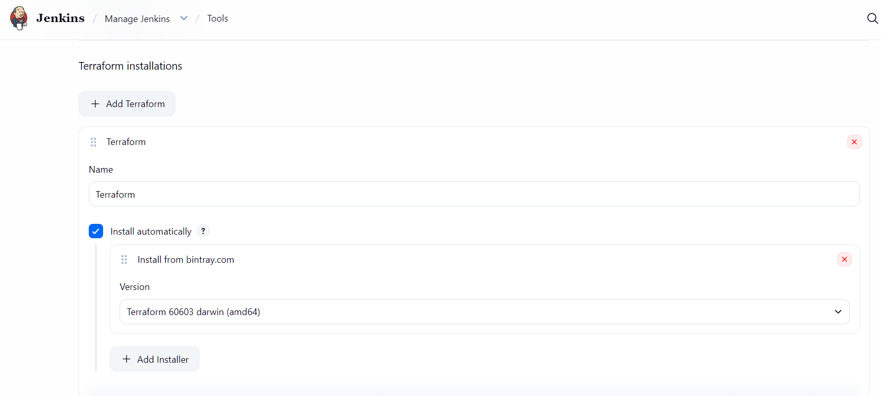
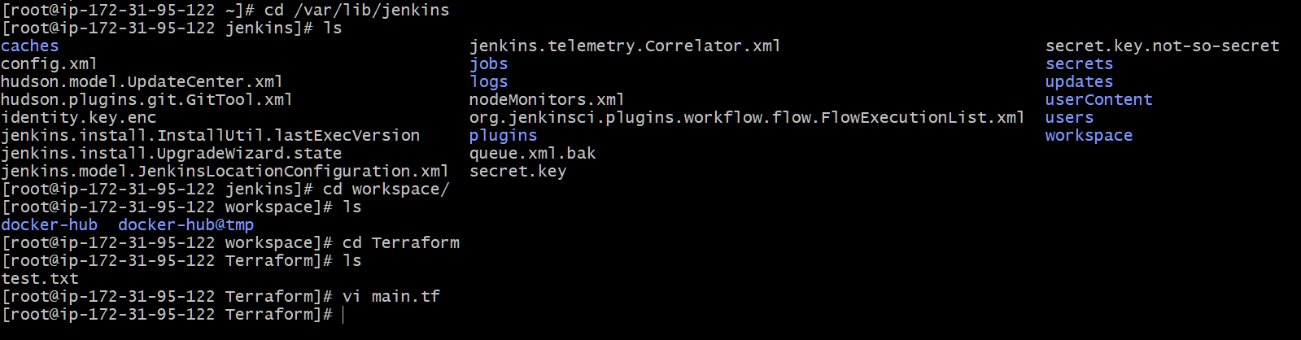
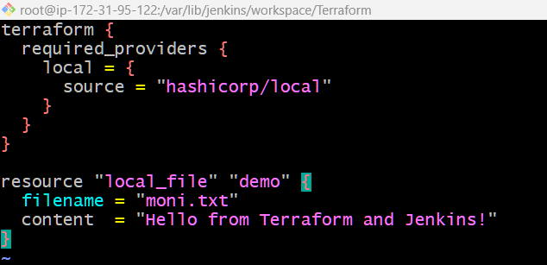

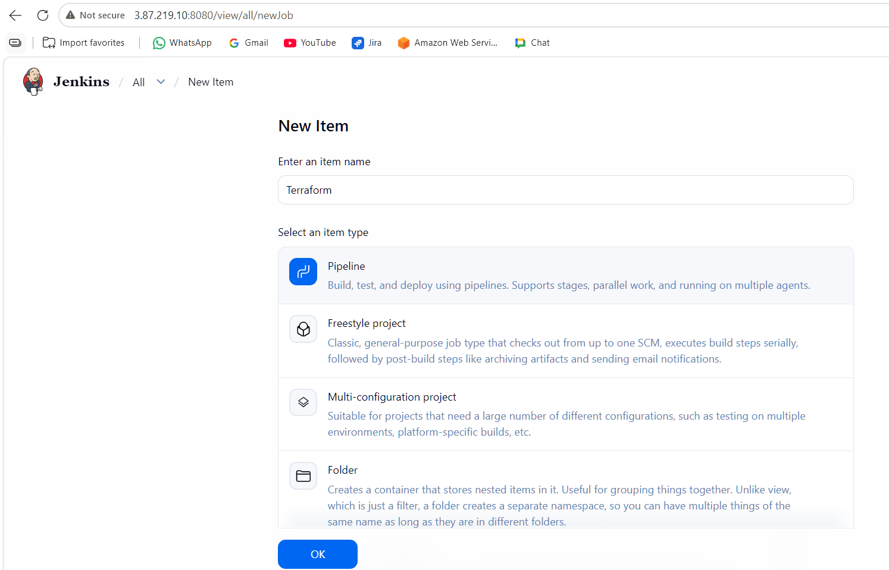
Write piprline script
pipeline {
agent any

stages {

stage('Terraform Init') {
steps {
sh '/usr/bin/terraform init'
}
}

stage('Terraform Plan') {
steps {
sh '/usr/bin/terraform plan'
}
}

stage('Terraform Apply') {
steps {
sh '/usr/bin/terraform apply -auto-approve'
}
}

}
}

The pipeline is build successfully
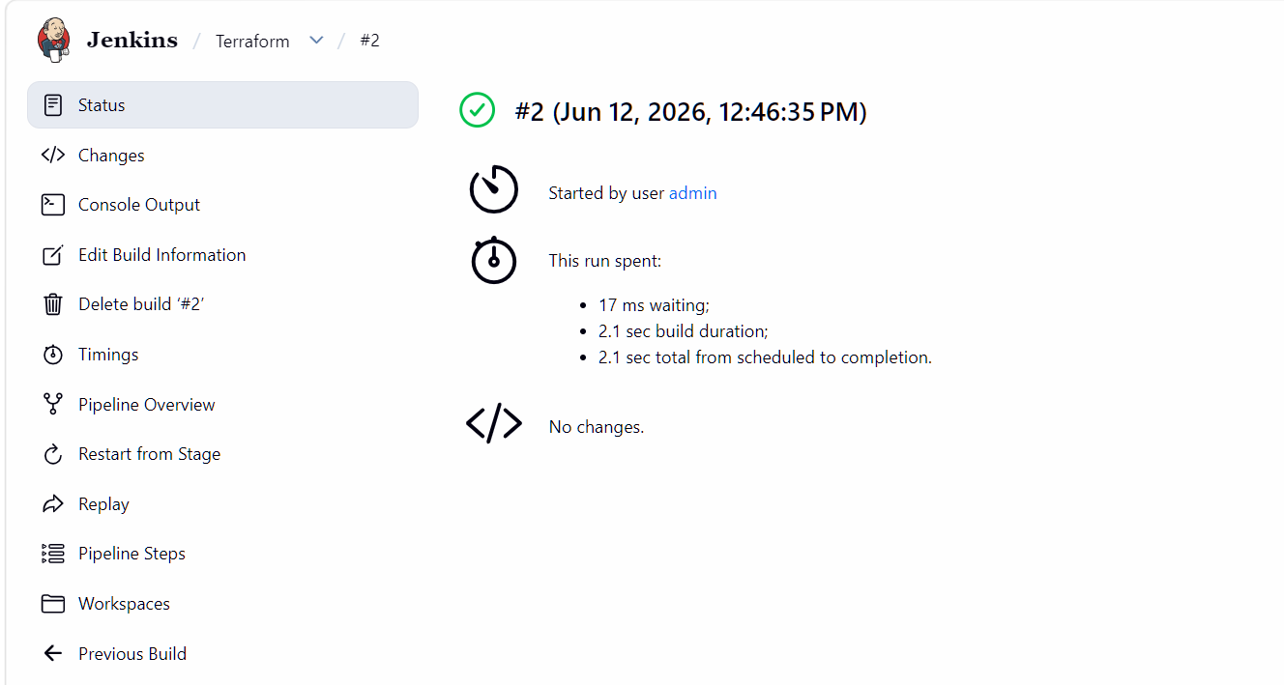
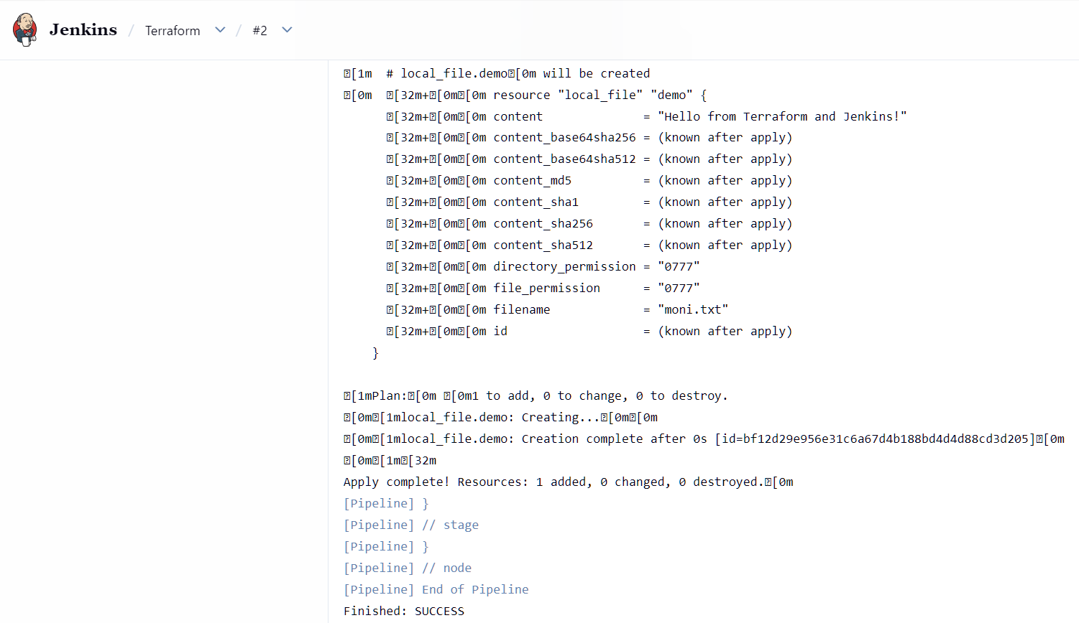
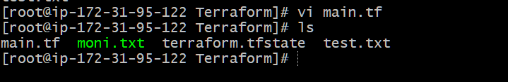

4.Create one Jenkins job using Maven Project for the code below with two stages:
  - Stage 1:Git clone
  - Stage 2:Maven CompilationCode:https://github.com/betawins/java-Working-app.git
Lets install maven integration first
Go to manage Jenkinspluginssearch for maven integrationclick on instal
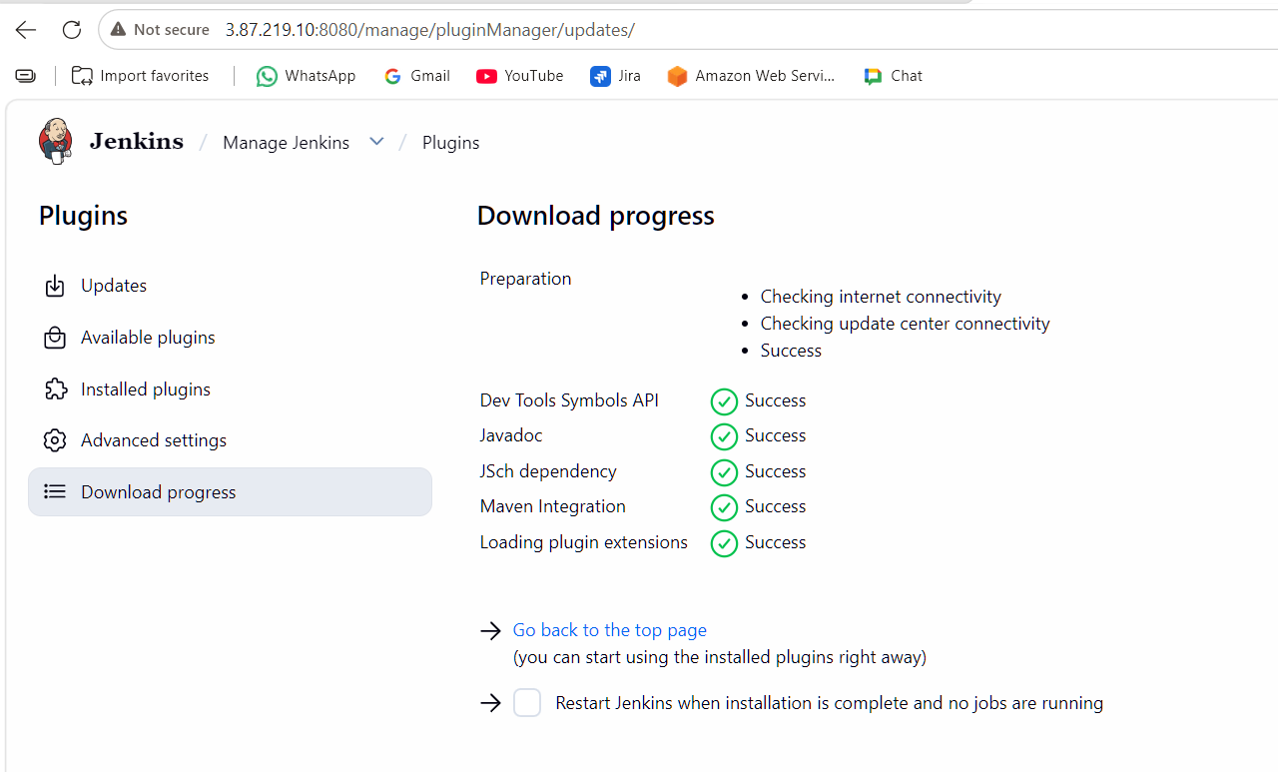
Go to manage Jenkins toolsclick on add mavengive namesave
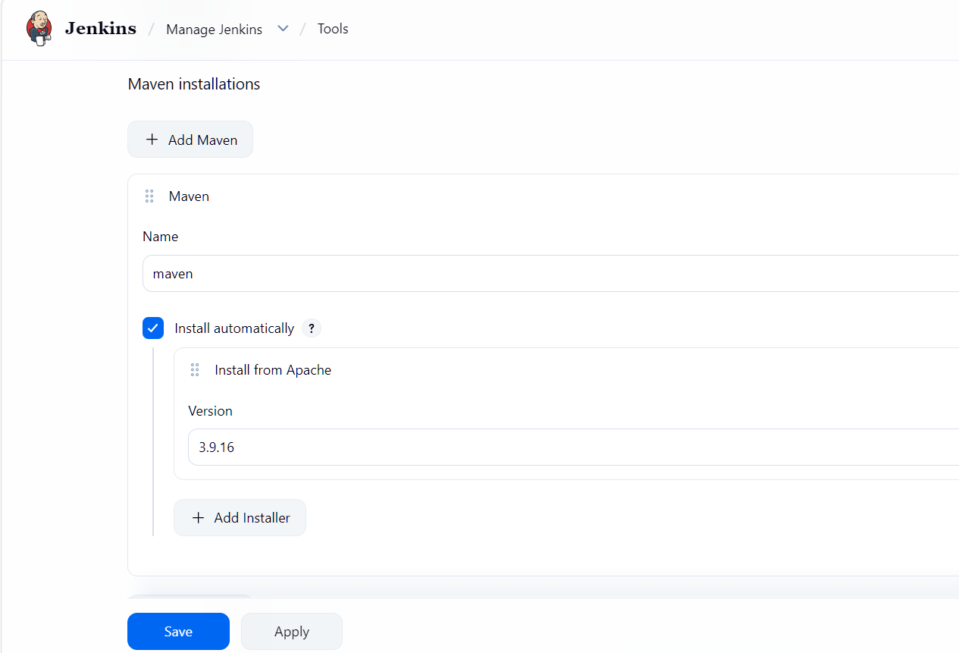
Now create a new job
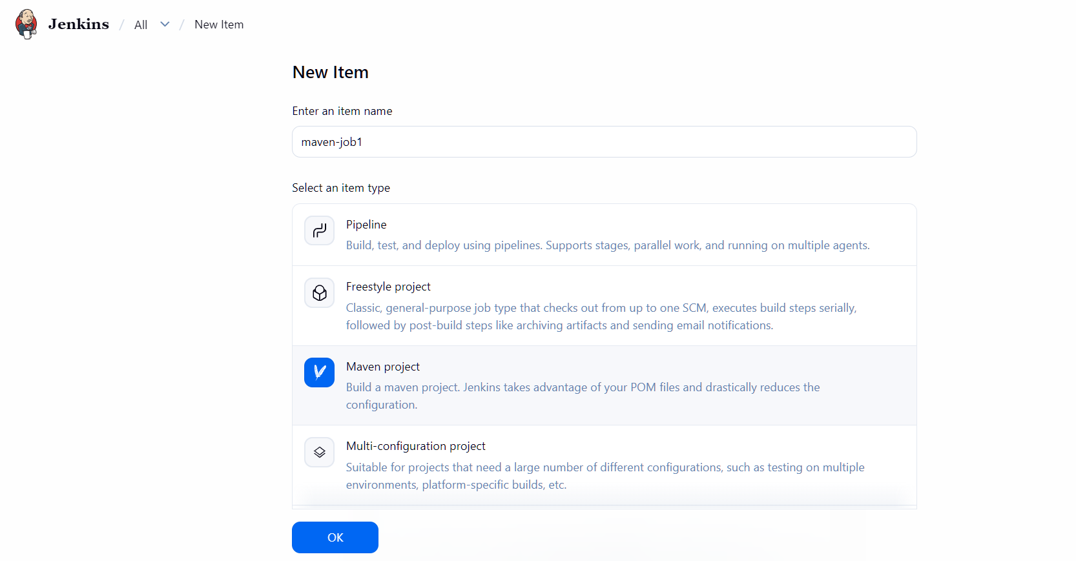
Stage 1 :git clone
Now lets select source management as git and paste the repo url and save it. Then run the job
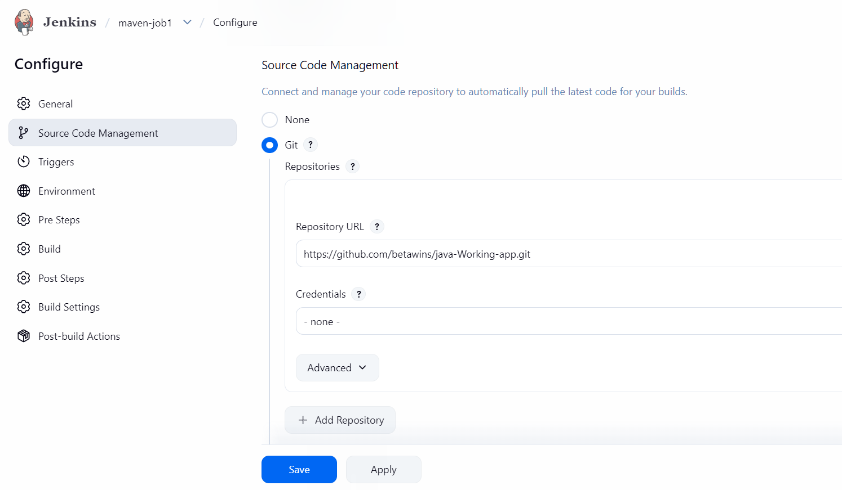
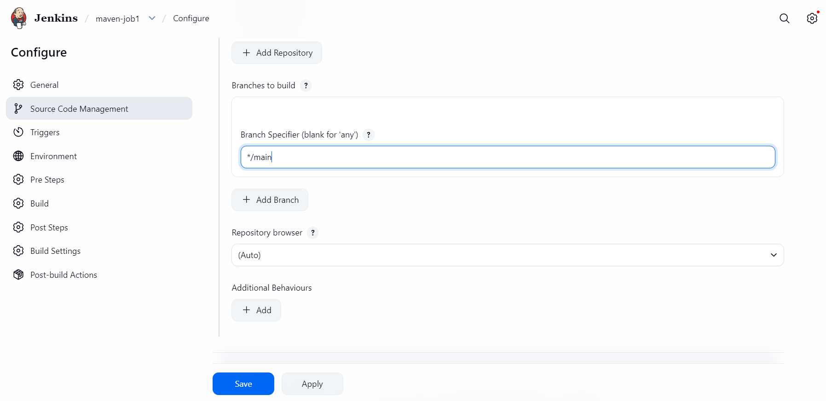
Job ran successfully
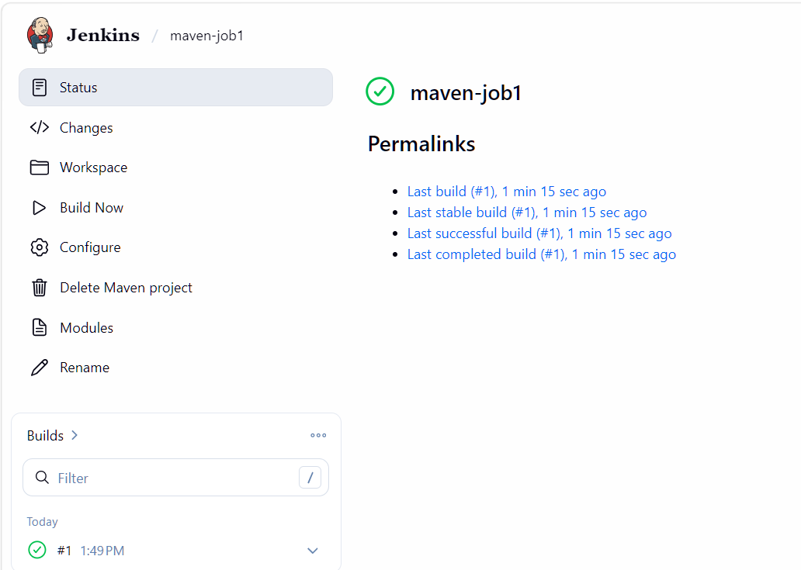
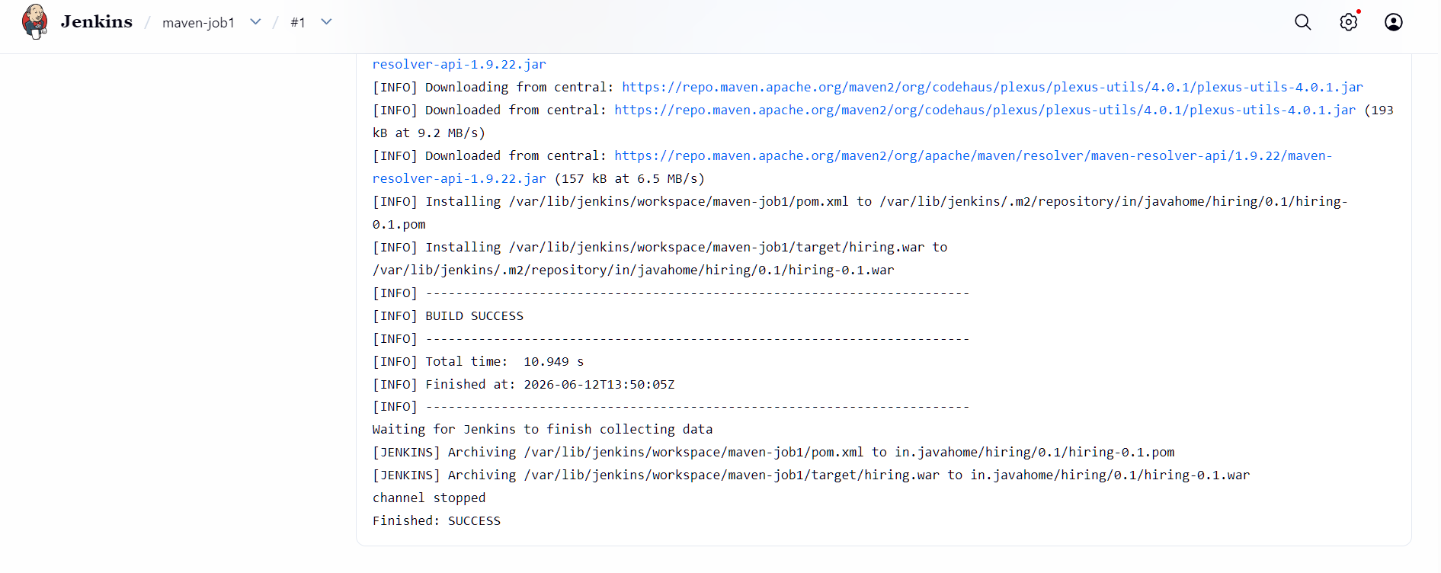

5.Use the same code and create a parameterized job in Jenkins with:
  - Stage 1:Git clone
  - Stage 2:Maven CompilationCode:https://github.com/betawins/java-Working-app.git
6.What are the global variables in Jenkins?

